Handout – Recommendations Activity
Goal : The Holiday Park company is struggling to keep generating income and are looking for actionable insights and specific recommendations of things they can stop doing/ do more/ do less or explore.
You can work independently on this goal or follow the step-by-step guidance on the next page.

  - Option a) Work independently

Help the Holiday Park company identify new business opportunities by spending time independently analysing their data, looking for trends and patterns, gaps and potential marketing/ team/ location changes.

You can focus on the who, where or when in their data, posing a question such as:
‘what is the most popular type of holiday/ park/ region?’
‘which salesperson/ location/ customer generates the most revenue?’
‘what times of year are most popular with solo travellers?’
Before trying to find answer to your question in the data with appropriate visuals, tooltips, actions and filters. All of techniques you have learnt should help lead your way to an actionable recommendation. Try to keep the insight specific and consider the less obvious patterns so that what you come up with will be different to the recommendations of your classmates. Your insight must be actionable – as in, there should be something the Holiday Park company can do, in response to what you have found.

It is also important to pay close attention to the final appearance of your visual(s); choose appropriate visual types, colours, titles and subtitles, consider axis labels and value formatting. Ask your tutor if you aren’t sure how to achieve something.

The final output of this task that you will share with the class will include:
i) polished individual visual or combination of visuals in a single sheet which illustrate the insight you have arrived at
ii) narrative accompanying the insight to explain what you have found, why you think it is important to the Holiday Park company – this can be displayed alongside the visual in a text box or if you snip the visual to another tool such as PowerPoint, can be added separately
iii) a recommendation to the leadership of the Holiday Park company to take specific action(s) based on the insight you have identified – this can be verbally shared with the class or indicated alongside your analysis.

  - Option b) Work in a guided way by following these steps and adding your own final touches

- As our aim is to discover ways to make more revenue for the Holiday Park company, we will focus on that value as well as two specific categories (dimensions) in our guided analysis (you can add more later) : Booking Source (Online, On Park, Contact Centre) and Holiday Type (Monday/Friday/Saturday weeks, seven nights plus, Midweeks). Alongside revenue we will examine the number of holidays booked, as this gives us an indication of revenue efficiency by volume – so the values(measures) we will look at are as a) the number of holidays booked (count of booking ID) and b) net revenue(aggregated as Sum and Average).

- Create a new sheet in your Holidays analysis, and pause to identify the above-described fields in the field list on the left hands side of your screen.

- Your first visual can be a pie chart, showing the proportion of bookings per Booking Source. Add visual> select visual type pie chart > select to highlight BookingSource + BookingID in the field list, noting the field wells allocation shown:
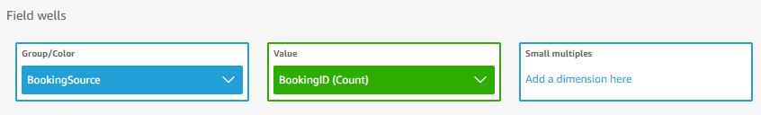

- Examine the chart, hovering over the segments to reveal the tooltips which indicate which Booking Source takes what volume of the bookings in the data. This reveals the contact centre takes the most bookings.
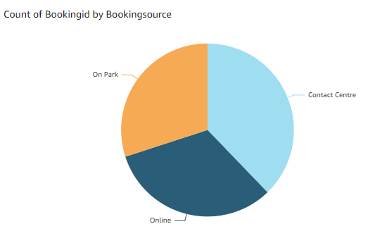

- Next, we will compare those bookings to the average revenue generated per booking – this will indicate which booking source is selling the more expensive holidays (one channel may be offering higher discounts more often, for example). To examine two values alongside each other we need two parallel y-axes (with different scales and different visual types. We will use a combo chart for this.

- Add new visual > select visual type clustered bar combo chart > select to highlight BookingSource+BookingID+NetRevenue, noting the field wells allocation shown:
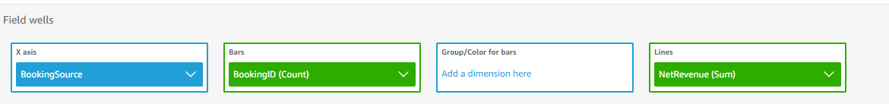

- Select the NetRevenue field which sits in the Lines field well, and from the drop-down menu, change the aggregation from Sum to Average.

- Examine the chart which indicate that although the contact centre Booking Source takes the highest volume of the bookings in the data, the average revenue (i.e., the total amount spent by the customer per booking) is lowest for that source.
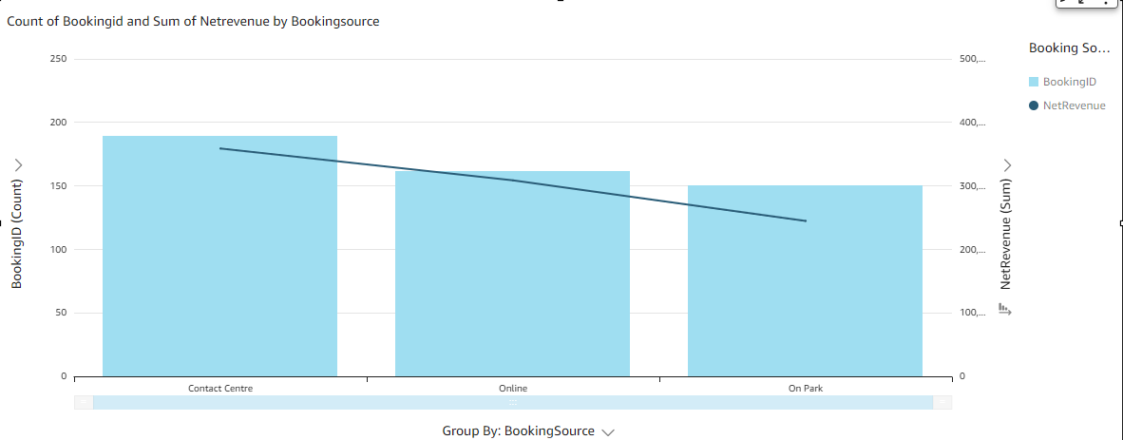

- Now we will look at which holiday types make the most money per booking channel.

- Add another visual to your analysis sheet, focusing on revenue per person. Add visual > leave visual type as autograph, select to highlight the field NetRevenue which will appear as one large value in the visual frame.
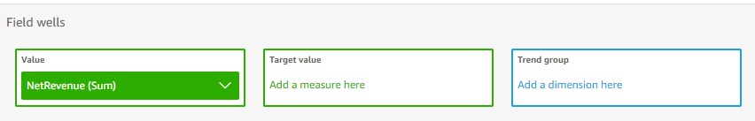

- Immediately change the aggregation type of the field netrevenue in the Value field well from Sum to Average.

- With your visual still selected, add BookingSource and HolidayType fields by selecting them from the fields list. This will lead to the creation of a horizontal bar chart with multiple-coloured bars per overall category.

- Note the field well allocations shown – you may need to swap the fields around to achieve the desired breakdown – per booking source, which holiday types make the most revenue, on average. Note the field allocations below:
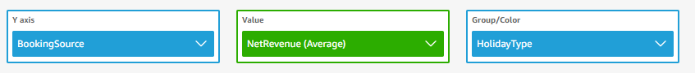

- Duplicate the visual to the sheet using the menu options on the top right of the colourful bar chart. Amend the field wells of the duplicate visual to focus on count of booking id. 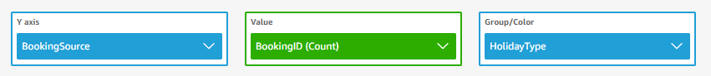

- These two charts side by side reveals the variance between holiday types that are frequently booked and the average revenue that they make, per booking source. Note that the contact centre sells the most Friday weeks and midweek holidays, but those make less money than the same holiday types sold online. Examine the visuals to spot more trends and variances in these two values and categories.
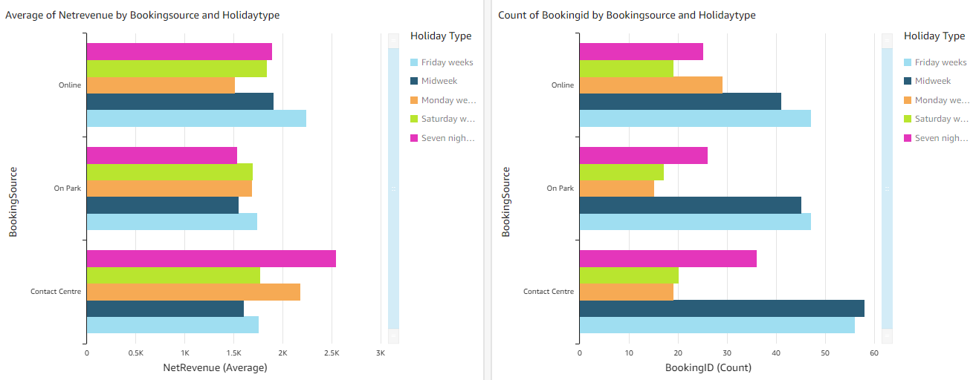

- To finish off your analysis (and before you have a go at more trend/pattern identification independently if you wish) spend some time formatting your visuals using the format menu as you saw in the lesson. Overwrite the title of each visual, consider axis labels and data labels, legend position/ hide, reference lines, allocating colours and amending the tooltips, any other visual changes which will help highlight specifically your findings and remove any unnecessary visual clutter. These changes will also help your analysis stand out from those of your classmates.

- Finally, insert a text box to your analysis to summarise what you have discovered by building these visuals and what your recommended actions to the Holiday Park business would be based on this. Your recommended action might include any of the following:
  - recommending a specific marketing campaign
  - website changes
  - offers and discounts to customers for certain holidays
  - staff training
  - any other ideas you have of things the company could do differently….

